The parameters of my quadcopter were determined by myself. In order to find data for your own quadcopter, you can reference chapter 21 of a Carbon Aeronautics Quadcopter Manual book and its author at this link:
https://www.youtube.com/@carbonaeronautics/featured
Motor and sensor simulation
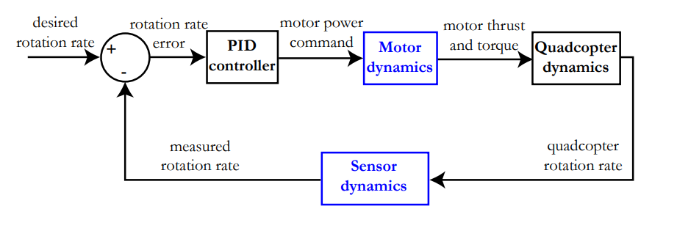
The thrust and current relation with the motor power evolves almost linearly; this means that you can simply perform linear regression in order to estimate the throttle-thrust and throttle-current relationship. For the brushless motor 1400kV motor and 8045 propeller combination, you can measure thrust and current, then you can display the relationship between current and throttle as the diagram below:
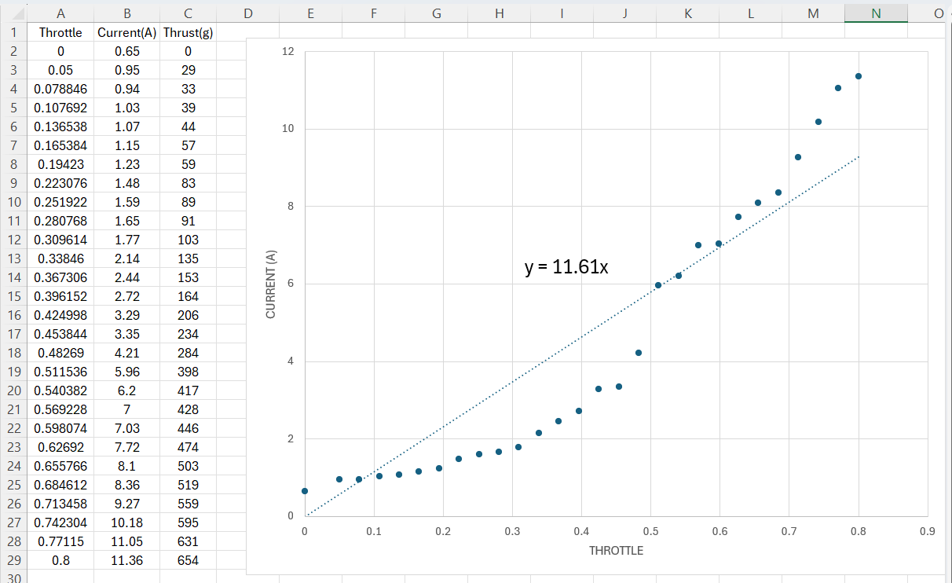
Throttle (80%) $→$ Thrust (654g)
Throttle (100%) $→$ Thrust (817.5g)
So, these relationships are:
thrust [g] = 817,5.throttle [0 : 1]
current [A]=$11,61$.throttle [0 : 1]
Where the throttle is a value between 0 (0%) and 1 (100%). The measurements from which these linear regressions are constructed were performed at a constant battery voltage of 12,6 V
Static motor modelling
When modelling your brushless motors, you are primarily interested in the relation between the throttle and the thrust provided by your motor-propeller combination, as well as the current consumption. A general rule in quadcopter design says that the maximal thrust generated by your four motors should be equal to two times the quadcopter weight, to ensure enough flexibility during flight. This means that one motor should generate about half the thrust necessary to hover the quadcopter. Your quadcopter weights around 960 gram (g), which means that the maximal thrust of one motor should be equal to at least 480 g.
For a quadcopter that weighs about 960 g, the motors need to provide a thrust equal to 4 x 240 g when hovering. Using the formula from the previous page, this corresponds to a power level for one motor of 240 / 654 = 0,367 or 36,7 %. The current consumption in this case will be equal to ${0,6412.e}^{3,6041.throttle[0:1]}=2,4$ Ampere (A) for each motor, or 9,6 A for all motors together. This means that a 2200 mAh (= 2,2 Ah) battery will be able to keep your quadcopter 2,2 Ah / 9,6 A = 0,23 h or 13,75 minutes in the air. In reality this value will be lower, as you do not only hover but also move the quadcopter around and accelerate, consuming more energy than during static hovering. The above calculation gives you nonetheless a good upper limit of the flight time.
Dynamic motor modelling
Besides the generated thrust and the consumed current of your motor, another important parameter is necessary for modelling; how fast does your motor accelerate when increasing the motor power? This is important because your PID controller generates a new command every 0.004 seconds, but your motor generally needs more time to accelerate/decelerate up to this desired value. The easy way to measure this (usually very short) time delay is muonting a small permanent magnets on a brushless motor and using hall sensor to measure the frequency of motor. The evolution of the motor frequency is visualised in the figure below:
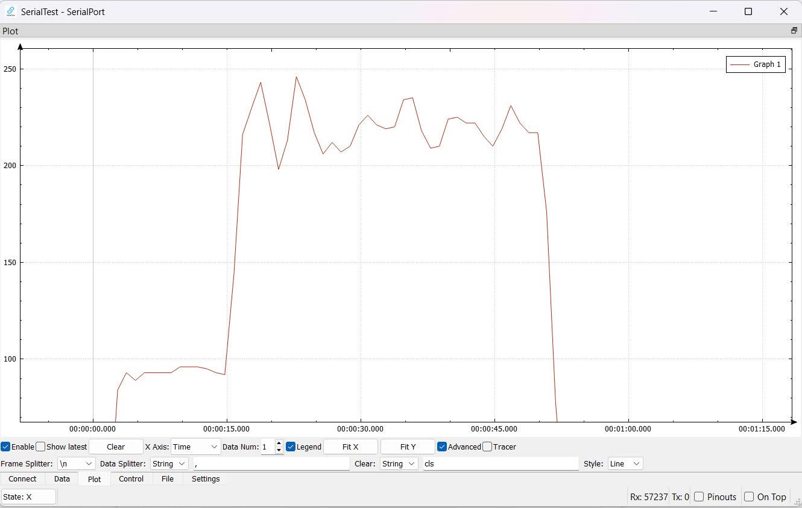
You can nicely follow the frequency increase from 95 Hz at a motor power of 10% to 220 Hz at a motor power of 50%. The time it takes for the motor to accelerate up to 220 Hz is equal to 2,23 seconds. This key piece of information will enable you to model the transfer function for the motor.
Transfer function for the motor response
You will now describe the time response of the motor compared to the command you have given to the motor mathematically. This is done using a transfer function. When looking at the behaviour of the motor visualized on the spectrogram, it resembles a first order response to a step input. Consider a general example in which a step input command of 1 is given at time = 0 seconds to your motor. Mathematically, this can be described as:
input(time)= 0 if time < 0
input(time)= 1 if time > 0
Describe now the first order response of a motor using one time-related parameter τ:
output(time) = (1 - $e^{-\frac{t}{τ}}$).input(time)
As visualised on the figures to the right with different step-response lengths, τ is defined as the time at which the motor output reaches 95% of the desired value divided by 3. For our motor, this gives a time parameter τ of τ=2,23 seconds/3 = 0,74 seconds. For further calculations, your transfer function needs to be written in the frequency domain, not the time domain. This means that you need the Laplace transform of the above equation. The Laplace transform of 1 is easy and equal to 1/s. In this notation, s is not the unit of time, but a complex number with the form s= σ+i.ω. You also know that the Laplace transform of $e^{-at}$ is equal to 1/(s+a) by convention, so transforming the above equation to the Laplace domain gives you:
output(s) = ($\frac{1}{s}-\frac{1}{s+\frac{1}{τ}}$) . input(s)
output(s) = $\frac{1}{τ.s+1}.\frac{input(s)}{s}$
And input(s)/s represents the unit step input considered in this example. In reality, you can have any input that you want, giving the final transfer function for a first order response:
output(s) = $\frac{1}{τ.s+1}.input\left(s\right)=\frac{1}{0,74s+1}.input\left(s\right)$
Dynamic sensor modelling
The state of your quadcopter (absolute angle and angular rates) is measured by a separate measurement system; the MPU-6050 sensor. This measurement system also has a dynamic response, as it does not respond instantaneously to the demands of your Teensy to provide some data on the quadcopter state. However, the sampling time of your MPU-6050 is equal to 1 kHz or 1000 Hz, which is much faster than the speed of your control loop (250 Hz). In addition, you also configured a 10 Hz low pass filter for both the accelerometer and the gyroscope in your code. With this filter, you are able to filter out unwanted high-frequency motor vibrations. Hence to model the time response of your MPU-6050 accurately, you only need to model its low-pass filter as its has the lowest frequency. The transfer function of any low-pass filter in the frequency domain is equal to:
output(s) = $\frac{ω_{c}}{s+ω_{c}}.input(s)$
where ωc =2.π.fc with fc being the cutoff frequency of the filter, 10 Hz in this case. This means that the frequency domain transfer function for your sensor becomes:
output(s) = $\frac{2.π.10}{s+2.π.10}.input(s)$
Now what does this practically mean in the time domain? Well, the transfer function can be transformed to 1/(1/(2.π.10)s+1), which gives a first order step response τ of 1/ 2.π.10 or 0.016 seconds. With this response, the same reasoning holds as with the motor response; any inputs that occur faster than 3.τ = 3. 0.016 seconds will be significantly attenuated. An input of 0.016 seconds (=τ) for example, is attenuated to 63% of its value as 1-e-0.016/0.016=0,63. A fast vibration with a response of 0.001 seconds gets almost fully attenuated: 1-e-0.001/0.016 = 0.06 or 6%. This is why configuring a 10 Hz low-pass filter in your MPU-6050 sensor was sufficient to filter out the high-frequency vibrations coming from your motors.
Roll and pitch motion
Let’s first try to describe the roll motion of the quadcopter in mathematical terms. To rotate the quadcopter in the roll direction, you need to apply a torque around the stationary x-axis: Torquex . The resulting angular acceleration. Accelerationroll in the roll direction depends on this applied torque, but also on the distribution of mass of the object. This mass distribution is described by the moment of inertia Ix , which results in the following relation:
${Acceleration}_{roll}[°/s^{2}]$ = $\frac{Torque [N · m]}{I_{x}[kg.m^{2}]}$
Where N is the unit Newton (equivalent to kg.m²/s²) and rad the angle unit radians. In order to convert the angular acceleration from radians/s² to °/s², the formula needs to be multiplied with 180/π (°/rad)
${Acceleration}_{roll}[rad/s^{2}]$ = $\frac{{Torque}_{x} [N · m]}{I_{x}[kg.m^{2}]}.\frac{180}{π}$
Torque around the x axis The torque around the x axis depends on the combination of the thrust from all four motors and the distance of each motor to the x axis:
$${Torque}_{x} \left[N.m\right]={Thrust}_{motor 3+4} \left[N\right].{distance}_{motor, x} \left[m\right]-{Thrust}_{motor 1+2} \left[N\right].{distance}_{motor, x} \left[m\right]$$
You already determined the thrust of one motor (in gram g):
thrust [g] = 817,5.throttle [0 : 1]
This can be transformed to N (or kg.m²/s²) by multiplying the result with 9.81 m/ s² (the gravitational constant) divided by 1000 g/kg. Moreover, you do not input a motor power between 0 and 1 but rather a value between 0 µs and 1000 µs through the parameter inputroll (although in the PID loop it is restricted to a maximal value of 400 µs). The formula transforms to:
thrust [N] = 817,5. $\frac{{input}_{roll}\left[0:1000\right]}{1000}.\frac{9,81[m/ s²]}{1000[g/ kg]}$
thrust [N] = 0,8175. ${input}_{roll}\left[0:1000\right].\frac{9,81[m/ s²]}{1000[g/ kg]}$
The value of ${input}_{roll}$is equal for all four motors, but has a positive sign for motors 3 and 4 and a negative sign for motors 1 and 2. This means that the torque formula can be rewritten as:
${Torque}_{x} \left[N.m\right]$= 4.(0,8175. ${input}_{roll}\left[0:1000\right]).\frac{9,81[m/ s²]}{1000[g/ kg]}.{distance}_{motor,x}[m]$
Moment of inertia around the x axis
The moment of inertia Ix in turn describes the weight distribution of the quadcopter and the distance of all components to the stationary x axis. Using the two-dimensional approximation of the quadcopter, the moment of inertia can be calculated as:
$$I_{x} \left[kg.m^{2}\right]=\sum_{i=1}{(}{mass}_{i} \left[kg\right].{distance}_{mass,x}^{2}[m^{2}])$$
Where ${mass}_{i}$is the mass of component i, and ${distance}_{mass, i}$ the distance between component i and the x-axis. Most weight of the quadcopter is situated very close to the x-axis: the battery and all the on-board electronics are stacked along the x-axis. Because this gives a very small distance, their contribution to $I_{x}$ is negligible. The weight of the frame is very small meaning that this contribution is also negligible. Therefore, the only components with a non-negligible weight and sufficiently far from the x-axis are the four motors, the arm frames and the ESCs. The formula reduces to:
$$I_{x}=4.{mass}_{motor}. {distance}_{motor,x}^{2}+4.{mass}_{arm frame}.{distance}_{arm frame,x}^{2}+4.{mass}_{ESC}.{distance}_{ESC,x}^{2}$$
$$I_{x}=4.0,061.{0,15}^{2}+4.0,038.{0,094}^{2}+4.0,032.{0,068}^{2}=0,0074 \left[kg.m^{2}\right]$$
Knowing that the mass of each motor (including propeller and bolts) is 61 g with a distance of 150 mm to the x axis, the arm frame weighs 38g with a distance of 94 mm and the ESC weighs 32 g with a distance of 68 cm to the x axis, you now have everything to calculate the angular roll acceleration
Roll and pitch dynamics
Introducing the formulas for the torque and the moment of inertia in the angular roll acceleration formula gives:
${Acceleration}_{roll}[°/s^{2}]$ = $\frac{4.(0,8175. {input}_{roll}).\frac{9,81}{1000}.0,15}{4.0,061.{0,15}^{2}+4.0,038.{0,094}^{2}+4.0,032.{0,068}^{2}}.\frac{180}{π}$
Which results in a very simple formula for the angular acceleration in the time domain:
${Acceleration}_{roll}[°/s^{2}]$ = 37,13 $. {input}_{roll}$
The angular roll acceleration can be replaced by the derivative of the roll rate, giving:
${\frac{d}{dt}(Rate}_{roll}[°/s^{2}])$ = 37,13 $. {input}_{roll}$
For the simulation of the PID controller, you want to have your equations in the frequency domain rather than the time domain. You can transform the time domain to the frequency domain by performing a Laplace transform to both sides of the equation:
${s.Rate}_{roll}[s]$ = 37,13 $. {input}_{roll}[s]$
In this notation, s is not the unit of time, but a complex number with the form s= σ+i.ω. This gives you finally the relation between the quadcopter roll rate and the input command given by the PID controller, which is called your quadcopter transfer function:
${Rate}_{roll}[s]$ = $\frac{37,13}{s}$ $. {input}_{roll}[s]$
You can construct a fully similar reasoning for the pitch dynamics, eventually giving the following formula:
${Rate}_{pitch}[s]$ = $\frac{37,13}{s}$ $. {input}_{pitch}[s]$

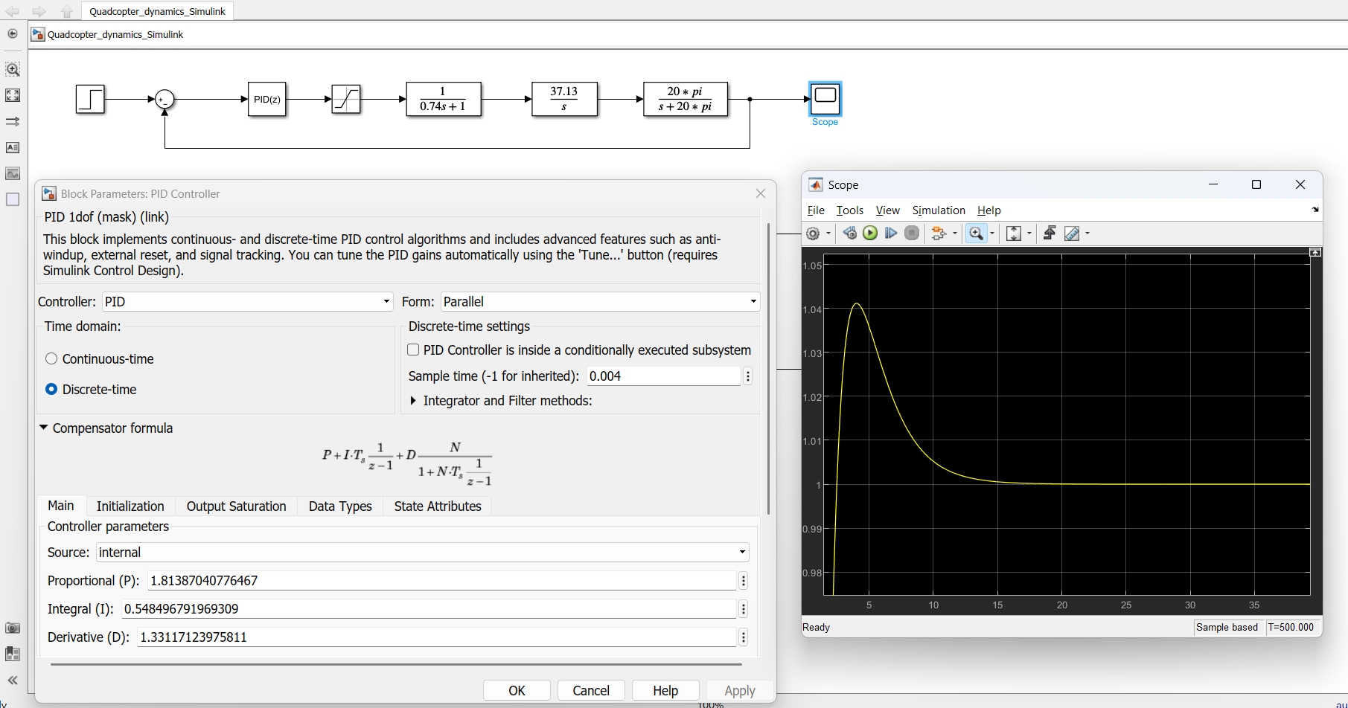
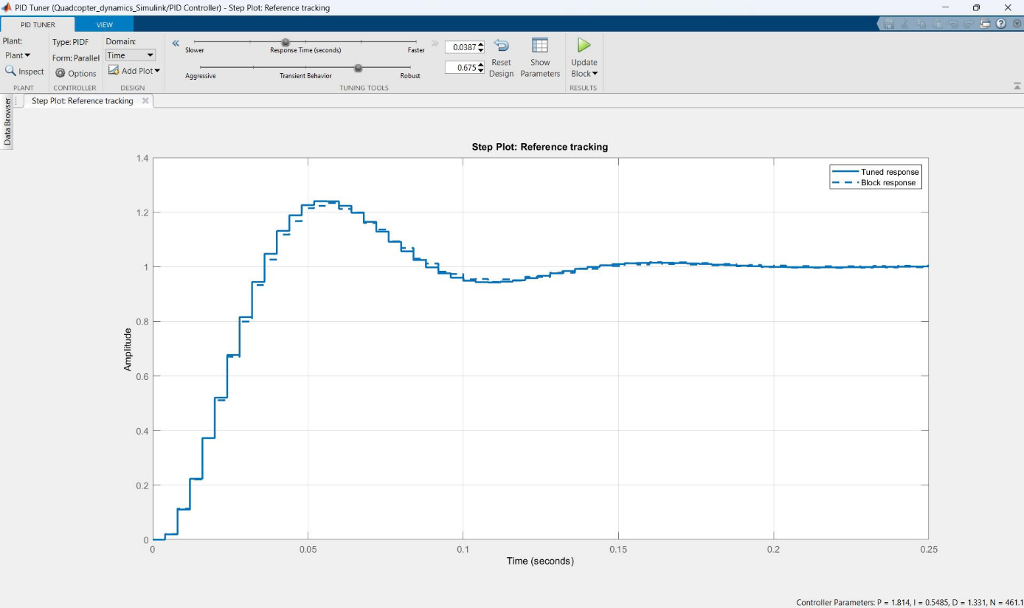

Yaw motion
The same basic equation for the angular acceleration in the yaw direction holds as for the roll and pitch direction, with the only difference being the torque and moment of inertia, which should be calculated around the stationary z axis:
${Acceleration}_{yaw}[°/s^{2}]$ = $\frac{{Torque}_{z} [N · m]}{I_{z}[kg.m^{2}]}.\frac{180}{π}$
Torque around the z axix
The torque around the z axis is equal to the sum of all four motor torques; the motor torque is opposite to the rotation direction of each motor. When the motor is spinning in a clockwise direction, the force of the air pushed against the propellers creates a torque in the counter-clockwise direction. The total torque around the z axis is then equal to:
$${Torque}_{z} \left[N.m\right]=-{Torque}_{motor1}+{Torque}_{motor2}-{Torque}_{motor3}+{Torque}_{motor4}$$
The torque for each motor is related to the motor current through the torque coefficient $K_{T}$:
$${Torque}_{motor} \left[N.m\right]=K_{T}.\left[\frac{N.m}{A}\right].Current \left[A\right]$$

This torque coefficient $K_{T}$can be estimated using the kV rating of the motor, which is in our case equal to 1400 kV or 1400 rpm/V:
$$K_{T}=\frac{60}{2.π.K_{v}}=\frac{60}{2.π.1400}=0,0068 \frac{N.m}{A}$$
You already determined that the current consumed by one motor is described by the formula below, which is already corrected for ${input}_{yaw}$between 0 and 1000 µs instead of a throttle between 0 and 1:
current [A]=$11,61$.throttle [0 : 1]
The value of ${input}_{yaw}$is equal for all four motors, but has a positive sign for motors 2 and 4 and a negative sign for motors 1 and 3. The torque formula results in:
$${Torque}_{z} \left[N.m\right]=0,0068.4.\left({0,6412.e}^{3,6041.throttle\left[0:1\right]}\right)$$
Moment of inertia around the z axis
The moment of inertia $I_{z}$describes the weight distribution of the quadcopter and its distance to the stationary z axis. In the two-dimensional representation, this gives:
$$I_{z} \left[kg.m^{2}\right]=\sum_{i=1}{[}{mass}_{i} \left[kg\right].{(distance}_{mass,i,z}^{2}\left[m^{2}\right]+{distance}_{mass,i,y}^{2}[m^{2}])]=\sum_{i=1}{(}{mass}_{i} \left[kg\right].{distance}_{mass,i,z}^{2}\left[m^{2}\right])$$
Notice that not only the distance of the mass to the x axis matters, but also the distance of the mass to the y axis. This is different compared to $I_{x}$, as the two-dimensional representation in that case meant that ${distance}_{mass,i,z }$is approximated as being zero. Once again only the components with a considerable mass that are far enough from the quadcopter X and Y axes are the motors and the ESCs.
This gives the following formula:
$$I_{z}=4.{mass}_{motor}. {distance}_{motor,z}^{2}+4.{mass}_{arm frame}.{distance}_{arm frame,z}^{2}+4.{mass}_{ESC}.{distance}_{ESC,z}^{2}$$
$$I_{z}=4.0,061.{0,212}^{2}+4.0,038.{0,132}^{2}+4.0,032.{0,096}^{2}=0,0148 \left[kg.m^{2}\right]$$
Knowing that the mass of each motor (including propeller and bolts) is 61 g with a distance of 212 mm to the z axis, the arm frame weighs 38g with a distance of 132 mm and the ESC weighs 32 g with a distance of 96 cm to the x axis, you now have everything to calculate the angular roll acceleration.
Yaw dynamics Introducing both formulas in the angular yaw acceleration formula gives:
${Acceleration}_{yaw}[°/s^{2}]$ = $\frac{\frac{11,61}{1000}.{input}_{yaw}}{4.0,061.{0,212}^{2}+4.0,038.{0,132}^{2}+4.0,032.{0,096}^{2}}.\frac{180}{π}=44,96$
Doing a similar Laplace transformation as before together with the integration of the acceleration results in the transfer function for the yaw dynamics:
${Rate}_{yaw}[s]$ = $\frac{44,96}{s}$ $. {input}_{yawl}[s]$
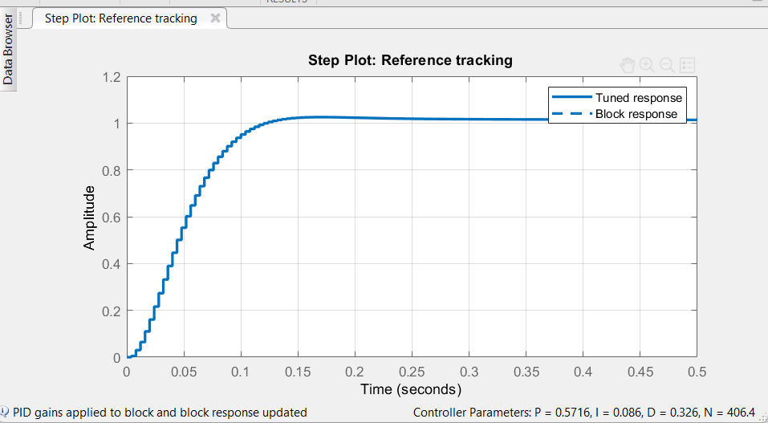
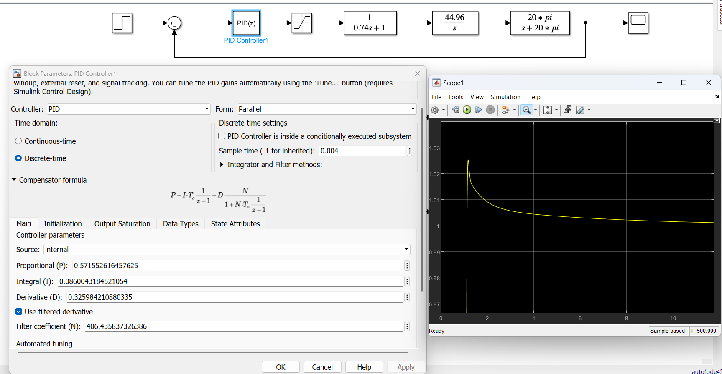
Vertical velocity dynamics
The mathematical description of the quadcopter dynamics along the stationary Z axis is rather intuitive; the resulting acceleration along this axis is equal to the thrust delivered by the motors minus the gravity acting on the quadcopter mass. Write this force balance as:
$${{mass}_{quadcopter}[kg] .Acceleration}_{z}[m/s^{2}]$$
= ${thrust}_{motor 1+2+3+4}\left[N\right]-{mass}_{quadcopter}\left[kg\right].9,81 [m/ s²]$
And the thrust of all four motors was already calculated previously as:
$${thrust}_{motor 1+2+3+4}\left[N\right]=4.0,8175.{input}_{throttle}\left[0:1000\right].\frac{9,81}{1000}=0,032.{input}_{throttle}\left[0:1000\right]$$
In the flight controller, you programmed input Inputthrottle as InputThrottle=1500+PIDReturn[0], because the zero velocity and thus the hover point will be at the point where the throttle stick is in the middle (1500 µs). This means that if you take this into account, the throttle stick at 1500 µs and gravity acting on the quadcopter mass cancel each other out. Knowing that the quadcopter mass is equal to 250 g, the dynamic equation of the acceleration along the z axis becomese:
$${0,96[kg] .Acceleration}_{z}[m/s^{2}]=0,032.{input}_{throttle}\left[0:1000\right]$$
$${Acceleration}_{z}\left[\frac{m}{s^{2}}\right]=0,033.{input}_{throttle}$$
When coding the flight controller, you did not measure the vertical velocity in m/s but rather in cm/s. Just multiply the equation by 100 cm/m to get the correct units:
$${Acceleration}_{z}\left[m/s^{2}\right]=3,3.{input}_{throttle}$$
Doing the same Laplace transformation as before together with the integration of the acceleration results in the transfer function of the vertical velocity dynamics:
${Velocity}_{Vertical}[s]$ = $\frac{3,3}{s}$ $. {input}_{throttle}[s]$
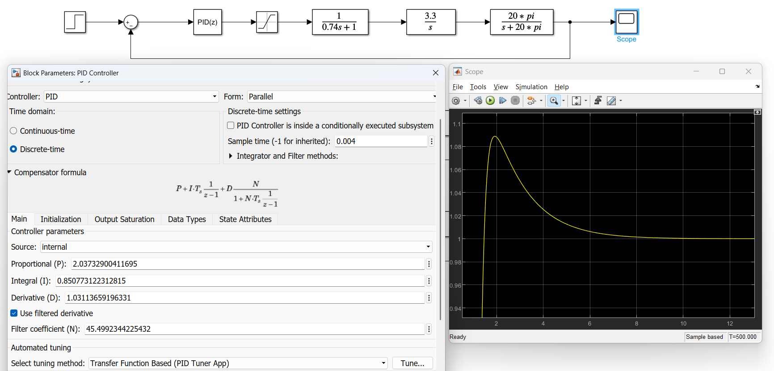
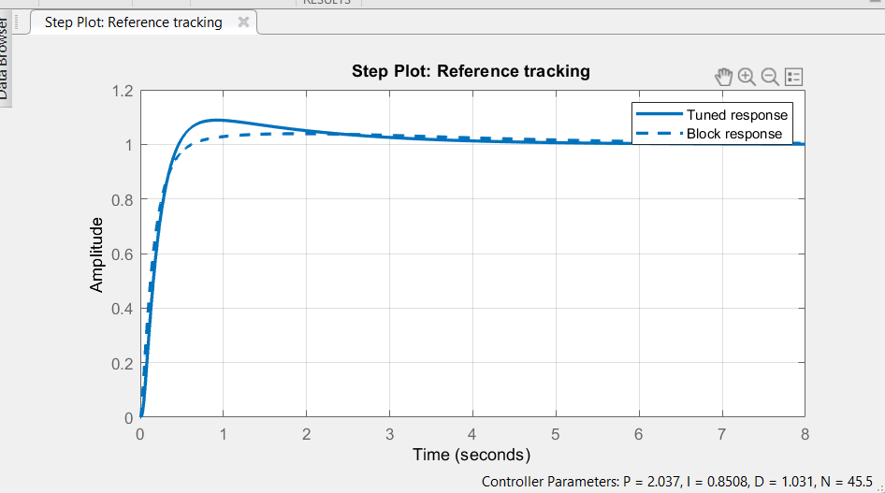
With the PID parameters determined for Roll, Pitch, Yaw, and Vertical, you can now apply them to your controller and fine-tune your craft yourself to achieve the most efficient performance.

